Contact: Ina Silvert Hillebrandt
Cell: (310) 497-5653
Email InaH@InasPawprints.com
Websites: http://YouAreWhoYouEat.net
http://InasPawprints.com
FOR IMMEDIATE RELEASE
August 12, 2016

"You Are Who You Eat" Cannibal Diet Author Ina Silvert Hillebrandt Says, "Nervous about Trump? Why Not Have Him for Dinner?"

Hillebrandt, responding to the wringing hands of millions on Facebook, offers solace in the form of sweet potatoes, and a great roast
Erie, PA, August 12, 2016 – After all the smoke and mirrors beginning Day 1 of the Republican Convention, followed by what appear to be a series of implosions, folks at You Are Who You Eat were not at all shocked to see the GOP, if reluctantly, still supporting Donald Trump as the Party's official elephant in the room.
In fact, author Ina Silvert Hillebrandt has been studying the Trump -- now of course TP -- campaign with keen interest from its inception in 2015.
"I never doubted for a minute that The Donald would keep on going this time. And as he has gone forward in his quest to nail the nomination, and our citizens, I have watched how some people have unmindfully followed him through every twist and turn. First it was all his guns pointed at women, then the media, Mexicans, Muslims, the KKK Footsie Dance and so much more. But, he's going to 'Keep America safe.' Well, we agree our country does need to be kept safe. Perhaps a little nosh will go a long way."
Hillebrandt, a seasoned diet guru whose new book You Are Who You Eat, The Revolutionary New Cannibal Diet, goes on to point out that any food's appearance is as important to keeping dieters on the right track with food as is the taste. Thus, she advises using mashed sweet potatoes as a perfect garnish for a Trump Rump Roast. You'll note in the photo at the top of the page the addition of California red table grapes for the eyes. Trimmings of the meat make up the nose. The fat lip needs no further explanation. Recipe attached to this release.

What is this book, and who is it for? Low cal tips like “Lay off fried people” make You Are Who You Eat the ideal weight loss guide for anyone who has trouble stopping after that first bite -- cannibal and civilian alike. And for people who relish cannibal jokes. Mouth-watering illustrations, previously unpublished, are by the late Playboy, Esquire, The New Yorker and Disney cartoonist Dedini. Former chubby teen-cum-consultant-to-Weight Watchers Ina Silvert Hillebrandt created the diet and cooking tips, along with ideas to nourish the inner cannibal (and non-imbibers) while slimming down Uncle Dan tossed social satire into the pot -- his origin stories for foodstuffs from around the world, as well as politicians, lawyers and more, are to die for. “Use Oil of Olé when sautéing Spaniards” just makes so much sense, especially when you see how he fleshes it out.

About the audience. Publisher Pawpress acknowledges that some members of the public, while intrigued, express confusion when seeing the cover and title of this book. Comments such as, “Is this a book about sex, Ina?” And, “That’s so true. You are what you eat!" (About half the book's readers auto-correct, not believing the word could be 'Who'). “This is a book about eating right, and dieting, right?” Upon looking inside, people who take the book semi-seriously at first, say, “Wait a minute… Is this tongue in cheek? Whose tongue? Whose cheek?” And, “Everybody is so concerned about nutrition and weight loss. It’s refreshing to just laugh about it.” Of course there are those who say, “Cannibals? Yick!” To which Ina replies, “To eat his own.”
HONORS: Publisher Pawpress is proud to note that in February 2016, You Are Who You Eat was added to the collection of The Billy Ireland Cartoon Library & Museum at Ohio State University, where a number of original cartoons featuring Dedini’s signature luscious women and lascivious men, along with other art, are housed. Dedini and his art were honored at a special exhibit at the Billy Ireland Feb-May.
# # #
ATTACHED
Author and Illustrator Bios
Photos
Trump Roast Recipe

Author and Illustrator Bios

Author Ina Silvert Hillebrandt - Spearhead Of 'You Are Who You Eat.' Even As A Young Kid, She Loved Playing With Her Food. Ina was always a foodie and indeed became a chubby pre-teen. Though she has remained slim, she's always been plagued by a fear of eating too much, or what she calls a "fat head." Which led her to years of studying and practicing every form of Weight Control on the planet. She finally graduated. Became a Fortune 500 marketing/strategic planning consultant. Early clients: Weight Watchers. And Dunkin’ Donuts. “Weight Watcher clients usually had donut crumbs on their lips,” she’s fond of recalling. She also worked for IBM, a lot of financial institutions, like Citibank, TV networks, airlines and food manufacturers, as well as nonprofits. These days, she’s a writing coach and publisher, and a writer. With screenplay and TV treatments in discussion for development. Books include bestsellers Pawprints – the book used in a Jane Goodall Educators’ Workshop that grew into a literacy program for kids, How to Write Your Memoirs, and Stories From the Heart, Vol. 2, a compendium of tales by students from different countries, and different eras. Her publishing arm has over a dozen titles, ranging from poetry to memoir, mystery to kids’ books.
About Dedini, Illustrator and Cover Artist
Eldon Dedini is best known worldwide for his cartoons in The New Yorker, Playboy and Esquire. The Billy Ireland Cartoon Library & Museum has an exhibit honoring him Feb 13-May 22. They have also added You Are Who You Eat to their Dedini collection. A fine documentary about the man showing his warmth, humanity, wit and love of life is available for all to see on YouTube. Links: http://YouAreWhoYouEat.net/about-illustrator-dedini/.
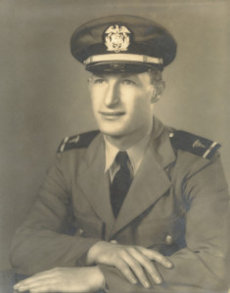
About Uncle Dan
Ina’s Uncle Dan contributed social satire, too many puns to count, and a fine sense of social justice to You Are Who You Eat. In his other life, he was recognized as an artist -- the top furniture refinisher in Philadelphia. And beloved as a man who was kind, generous and one who supported important cultural and social institutions, including the Philadelphia Libraries.
Our Founding Spear-It, Ina’s Dad, Abe Silvert
You Are Who You Eat is really a family affair. Ina’s dad started the cannibal joke tradition. A born storyteller, he kept two young kids (Ina and her brother Conrad) from committing suicide on 3,000 mile car trips every year -- driving from Philadelphia to Los Angeles and back again -- by telling all sorts of tales, many true. Related to this book – he’d be talking, then suddenly, silent. Ina and Conrad never worried. Sure enough, a minute later, out would come a cannibal joke. The rest is history.
More…
Print resolution files available on request. 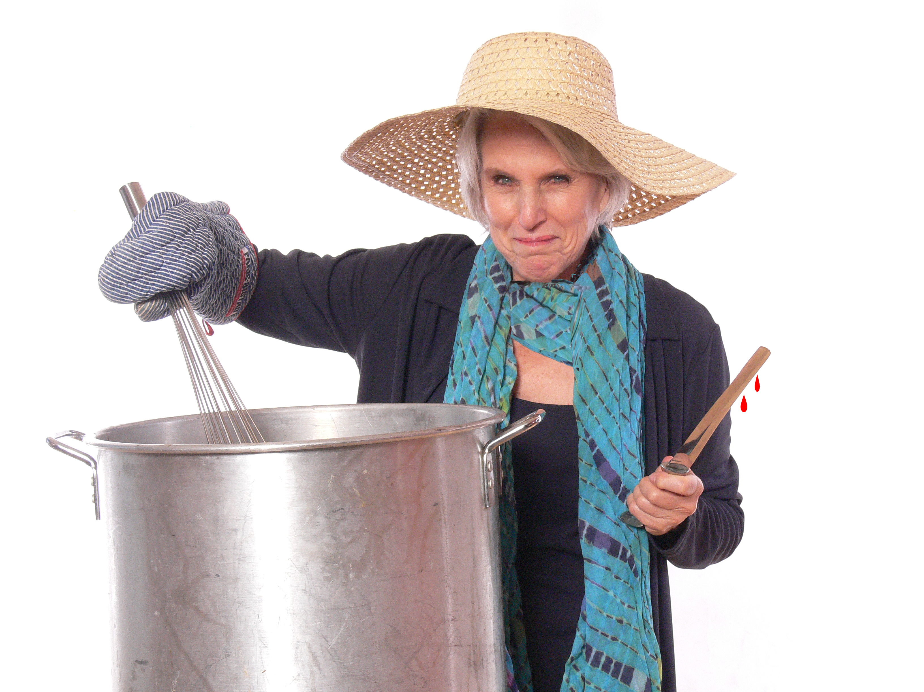

Ina Silvert Hillebrandt, Author, You Are Who You Eat, The Revolutionary New Cannibal Diet

From Recipe Companions, for
You Are Who You Eat,
The Revolutionary New Cannibal Diet
By Ina Silvert Hillebrandt

TRUMP ROAST -- MAKE AMERICA grEAT AGAIN!

Ingredients
1 Trump Roast, 4 lb., room temperature
3 garlic cloves, cut in half

1 Tb salt

1 Tb pepper

1 large onion, coarsely chopped

½ cup red wine (American)

½ cup water

Garnish

4 large sweet potatoes

More salt, pepper, plus cinnamon and nutmeg to taste

2 large green olives, stuffed with pimientos

2-3 cannelloni beans (cooked/canned)

1 baby corn (from jar)

Directions
- Pre-Heat the oven to 500 degrees.
- Prep the roast by making 4-5 slits in its sides, and filling each of the slits with some of the salt and pepper, and 1/2 of a clove of garlic.
- Salt and pepper the surface of the roast. Put into roasting pan with high enough sides to hold liquids.
- Take sweet potatoes, wash and scrub. Wrap in aluminum foil. Put the potatoes onto a separate baking dish or tray.
- Put both potatoes and roast in the oven and sear roast for 20 minutes.
…..More
- To the roast pan, add the water, wine and chopped onion. Reduce the temperature to 275 degrees.
- Leaving potatoes in the oven, cook roast for 20 minutes per lb. for rare, 25 minutes for well done.
- Remove roast from oven, letting it sit to absorb juices.
- Leaving potatoes in the oven, cook roast for 20 minutes per lb. for rare, 25 minutes for well done.
- Remove roast from oven, letting it sit to absorb juices.
Sweet potato assembly
Remove skin from sweet potatoes, putting the flesh into a bowl.
Add 1-2 TB butter
Add salt, pepper, nutmeg and cinnamon to taste.
Mash the potatoes and seasonings to form a smooth consistency. (Food processor OK, but blender will over fluff.)
How to Garnish
First, put the roast onto a nice platter. Red, white and blue best choice.
Arrange the sweet potatoes into hair. Think "The Donald's" signature shape.
Use the olives for eyes.
Corn for nose.
Cannelloni beans for the mouth.
Et voila! Whoops. Not a good idea to use a foreign tongue. Let's just say Yay! You and your guests have a terrific, lean entrée and built-in side dish.
NOTE:
You might want to complete the meal with a Caesar salad. As a tribute to the main dish, remember to salute with a full bodied American red wine, such as a Cabernet, and the toast, "Hail, Caesar!"

The Cannibal Motto:
To Eat His Own
™
Trump Roast Recipe © 2016 Ina S. Hillebrandt
To go with the book, You Are Who You Eat, The Revolutionary New Cannibal Diet
_____________________________________________________________
http://YouAreWhoYouEat.net http://www.Facebook.com/YouAreWhoYouEat Twitter: #cannibaldiet

